**Real-time keypad shortcuts**

**Reference Sheet V1.0**

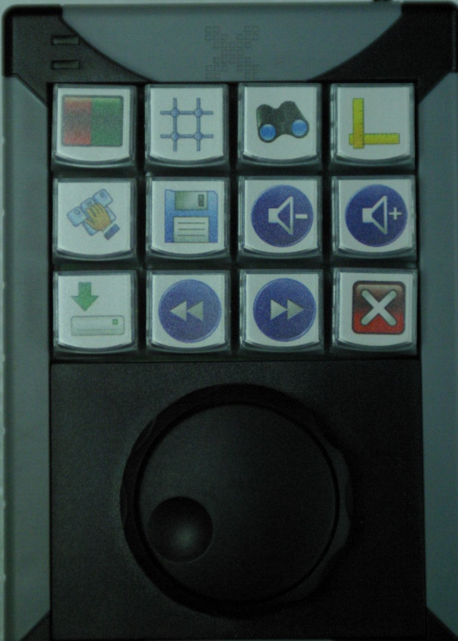

Shuttle (outer ring) - Selection of clock hour for scan

(F11 & F12 keys)

Jog (inner wheel) – Selection of gain in real-time or image in browse of last N

(Shift+F1 & Shift+F2 keys)

C:\Documents and Settings\jketterling\Desktop\Untitled-1.jpg Start/stop real-time scan [Button 1: F1 key]

C:\Documents and Settings\jketterling\Desktop\Untitled-1.jpg Scale data to a 1:1 mm aspect ratio [Button 4: F2 key]

C:\Documents and Settings\jketterling\Desktop\Untitled-1.jpg Fill full display space with image [Button 7: F3 key]

C:\Documents and Settings\jketterling\Desktop\Untitled-1.jpg Auto-scale x and y axis [Button 10: F4 key]

C:\Documents and Settings\jketterling\Desktop\Untitled-1.jpg Open sub-window and browse/save last-N images [Button 2: F5 key]

C:\Documents and Settings\jketterling\Desktop\Untitled-1.jpg Save last-N images to PC (real-time or last N images window) [Button 5: F6]

C:\Documents and Settings\jketterling\Desktop\Untitled-1.jpg Decrease Daxsonics drive voltage [Button 8: SHIFT+F4keys]

C:\Documents and Settings\jketterling\Desktop\Untitled-1.jpg Increase Daxsonics drive voltage [Button 11: Shift+F3 keys]

C:\Documents and Settings\jketterling\Desktop\Untitled-1.jpg Real-time stream of images to PC [Button 3: F7 key]

C:\Documents and Settings\jketterling\Desktop\Untitled-1.jpg Lower frame rate [Button 6: Shift+F5 keys]

C:\Documents and Settings\jketterling\Desktop\Untitled-1.jpg Increase frame rate [Button 9: Shift+F6 keys]

C:\Documents and Settings\jketterling\Desktop\Untitled-1.jpg Exit current window. Stops scan if in main window. [Button 12: ESC key]

When data files are saved, an eye file and a jpg image are saved of the synthetically focused data.